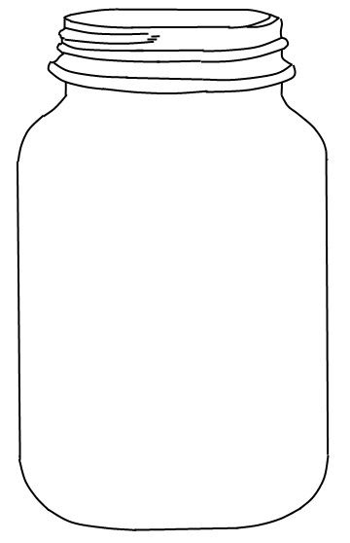
Name:
Primary school:
Age:
My ultimate dream:

………………………………………………………......
………………………………………………………………………………………………………………………
………………………………………………………………………………………………………………………
………………………………………………………………………………………………………………………
………………………………………………………………………………………………………………………
………………………………………………………………………………………………………………………
………………………………………………………………………………………………………………………
………………………………………………………………………………………………………………………
………………………………………………………………………………………………………………………
………………………………………………………………………………………………………………………

